West Chester Apartment Housing Association
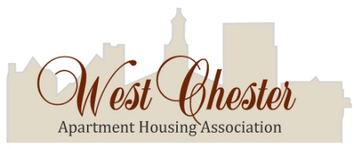
MEMBERSHIP APPLICATION
A Non-Profit [501 (c)6] Corporation
Mission Statement
OUR GOAL is to maximize the satisfaction of all people associated with the renting of residential apartments in the Borough of West Chester. By bringing together responsible apartment investors and landlords in an organization, we envision that we can best address common concerns of the community.
WE BELIEVE that through cooperation and mutual responsibility among public and private organizations and community residents, resources can be organized and mobilized that help strengthen social supports and institutions, develop enlightened leadership, build a strong infrastructure, and promote a clean and safe community.

Phone: 610-696-1140

Fax: 610-696-5024
Email: wcahaman@aol.com Website: www.wcaha.com
Please make checks payable to WCAHA
620 South Franklin Street, B18, West Chester, PA 19382
Dues: 1-4 units=$60, 5-29 units=$15 per unit , 30+ units $450. All dues are per calendar year.
Name: | Contact Person:
Name as registered w/WC Boro Housing Office: | Company name (if applicable):
Street Address: | Phone#: Fax #:
City, State, Zip: | Email address:
Township: | Are you eligible to register/vote in West Chester?  Yes _________ No ____________
Primary business: | Interests as a member: (concerns, ideas, volunteer interests…)
Rental Property location(s): | Number of units:
Office use only
Ck # Ck Dated Ck $ Amt Deposit Date
Word: wcaha: applications: 2019 member application

